AWS Change Runbook: Git → Pipeline → Change Set
Oct 23, 2026 · @Kunal Shrivastava
Every AWS change goes through Git and a reviewed change set. Developers: use Section 1. New to Git or the pipeline: read Section 2, which explains each step with screenshots.

Section 1 — Quick steps (developers)
Edit the template on a branch, get the PR approved by two people and merged, run the pipeline from main with Deploy = no, review and execute the change set in the console, and close the CR.
Task details (sandbox example)
Item | Value
Account (OU) | <sandbox-account-name> (Non-Production)
Region | <region>
Stack | sbx-runbook-demo
Template | non-production/<sandbox-account-name>/sbx-runbook-demo.yaml
Change | Enable versioning on DemoBucket
Pipeline | <cfn-deploy-workflow> (drift check and change set), run from main
Pipeline parameters | template = the Template path above · Deploy = no
Expected pipeline result | Green run; drift check IN_SYNC; change set created and named in the log; nothing executed
Expected change set | 1 row: Modify · AWS::S3::Bucket · Replacement False
Verify | S3 › bucket › Properties › Bucket Versioning = Enabled
Other pipelines: stacks on the direct deployment list (JSON settings, e.g. Firewall Manager policies) use <direct-deploy-workflow>; trust stores use <truststore-workflow>. See Which pipeline to run.
Change
DemoBucket:
Type: AWS::S3::Bucket
Properties:
+ VersioningConfiguration:
+ Status: Enabled
Steps (numbers match Section 2, which explains each one with screenshots)
Step | Do this
1–3 | Open the template from Task details. Unsure it's the right file? Search the stack's Description in GitHub.
4 | Repo → Branches → New branch: <type>/<JIRA-ID>-<short-description> from main.
5 | Open your branch → the template → pencil icon → apply the change → Commit changes to your branch.
6 | PR to main titled <CHG-number> <account> <resource>: <what changed> → two approvals → Merge pull request → delete the branch.
7 | Actions → the Task details pipeline → Run workflow from main with the Task details parameters. The run must match Expected pipeline result.
8 | CloudFormation → stack → Change sets → open the new one. It must match Expected change set: no Remove, no Replacement = True. Direct deployment: skip this step.
9 | Execute change set → wait for UPDATE_COMPLETE (CREATE_COMPLETE for a new stack) → run the Verify check. Direct deployment: the pipeline has already deployed, so just run the Verify check.
10 | Add the PR link, run link, change set name and final stack status to the CR in ServiceNow, then close it.
You need: GitHub write access, SSO <permission-set> on the account, and an approved <CHG-number> for production. Problems: see Troubleshooting at the end of Section 2.

Section 2 — Reference guide (non-developers)
How to find the code, create a branch, commit, raise a PR, run the pipeline and review the change set and close the CR, with screenshots from one sandbox run.

How to implement a change: end to end
Every AWS change is made in code: you edit it in GitHub, two people approve the PR, the pipeline creates a CloudFormation change set, and you review and execute it in the AWS console. Nothing changes in AWS until you click Execute change set.
Follow these stages in order; each links to the step that explains it, with screenshots.
- Is there a stack for this resource, or do I need a new one? Find the resource in the AWS console and check its aws:cloudformation:stack-name tag (Step 1, Step 2).
  - Stack found → change that stack's template.
  - Resource doesn't exist yet → add it to a related stack's template in the same account, or create a new template; a new template becomes a new stack.
  - Resource exists but has no stack → stop. Contact <owner>; don't recreate it.
- Where is its code in Git? Copy the stack's Description and search for it in GitHub. No match → open the OU folder, then the account folder. New stack → a new file in the account folder (Step 3).
- Make the change. Create a branch, edit the file with the pencil icon, and commit (Step 4, Step 5).
- Get it approved and merged. Raise a PR to main, and merge it after two approvals (Step 6).
- Which pipeline do I run after the merge? Usually the change set pipeline: Actions → <cfn-deploy-workflow> → Run workflow from main, with the path of the file you changed and Deploy = no. Stacks on the direct deployment list use <direct-deploy-workflow> instead (Which pipeline to run, Step 7).
- What should I see while it runs? First the drift check: IN_SYNC → carry on; DRIFTED → stop. Then the change set is created, its name is printed, and the pipeline stops. The direct deployment pipeline has neither; it deploys straight away (Step 7).
- Review and execute the change set. Open it in the CloudFormation console, check every row, then click Execute change set. Direct deployment: skip this stage (Step 8, Step 9).
- Verify in AWS. The stack reaches UPDATE_COMPLETE (CREATE_COMPLETE for a new stack), and the resource shows your change (Step 9).
- Close the CR. Add the evidence to the CR in ServiceNow, then close it (Step 10).
Applies to: all accounts in the Production and Non-Production OUs.
Running example (sandbox): enable versioning on S3 bucket sbx-runbook-demo-<account-id> in <sandbox-account-name>. Every step shows the example values, and every screenshot comes from this one run.

Before you start
You need write access to the repo and AWS SSO access to the target account.
- ☐ Write access to GitHub repo plat-eng/AWS-Landing-Zone on tescoims.ghe.com
- ☐ AWS SSO access to the target account with permission set <permission-set> (to view and execute change sets)
- ☐ Target account name, account ID and region <region>
- ☐ Production only: approved change record <CHG-number>

Rules
- Never edit a stack-managed resource in the console. Change the code; console edits cause drift.
- One change = one branch = one PR = one change set. Name branches and PRs by the IMS rules (Steps 4 and 6); delete your branch once merged, and close PRs you abandon.
- Every PR needs two approvals before it's merged. Run the pipeline from main straight after the merge, so main always matches what's deployed.
- Read every change set before executing. An unexpected Remove or Replacement = True means stop.
- Don't touch stacks named StackSet-*; they're deployed centrally. Contact <owner>. Stacks on the direct deployment list <link> (JSON settings, e.g. Firewall Manager policies) go through <direct-deploy-workflow>, not the change set pipeline.
- New to this? Run the sandbox example first.

Repo layout: OU ↔ folder
The top-level folder matches the account's OU; the next folder is the account.
[Screenshot S1] Your OU diagram: Root → Production OU / Non-Production OU → accounts. Label each OU with its repo folder name.
AWS OU | Repo folder | Accounts (examples)
Production | production/ | <app>-prd
Non-Production | non-production/ | <app>-dev, <app>-tst, <app>-ppe, <sandbox-account-name>
<repo>/
├── .github/workflows/
│ └── <cfn-deploy-workflow>.yml
├── production/
│ └── <prd-account-name>/
│ └── <stack-name>.yaml
└── non-production/
├── <dev-account-name>/
└── <sandbox-account-name>/
└── sbx-runbook-demo.yaml ← running example
Path rule: <OU folder>/<account folder>/<stack-name>.yaml
[Screenshot S2] GitHub repo root with production/ and non-production/ expanded down to one account folder.

Which pipeline to run
There are three pipelines. All run from Actions on main, after the PR is merged; pick the one that matches what you changed.
Pipeline | Use it for | Parameters | Expected result
<cfn-deploy-workflow> — drift check and change set | Most CloudFormation changes | template = path of the file you changed · Deploy = no | Green run; drift check IN_SYNC; change set created and named in the log; nothing executed. You execute it in the console (Steps 8–9).
<direct-deploy-workflow> — direct deployment | Stacks with resources CloudFormation can't drift-check because they hold JSON settings, e.g. Firewall Manager policies. These are on the direct deployment list <link>. | template = path of the file you changed · <direct-deploy-inputs> | Green run; stack UPDATE_COMPLETE (or CREATE_COMPLETE). No drift check and no pause to review a change set: it deploys as soon as it runs.
<truststore-workflow> — trust store | CloudFront mTLS trust store certificates | environment · apply = no (dry run), then yes | Dry run: validation passes and the S3 diff shows only your change. Apply: trust store updated. See the trust store runbook.
The change set pipeline can also execute the change set itself (Deploy = yes). Keep no, so the change set is reviewed in the console before anything changes.
With direct deployment, the PR review is the only check before AWS changes, so reviewers must read Files changed line by line.
[Screenshot S2a] GitHub › Actions: the workflow list on the left. Highlight: the three pipelines.
↑ Back to the end-to-end summary

Decision flow
Answer the questions top to bottom; each outcome names the step that covers it.
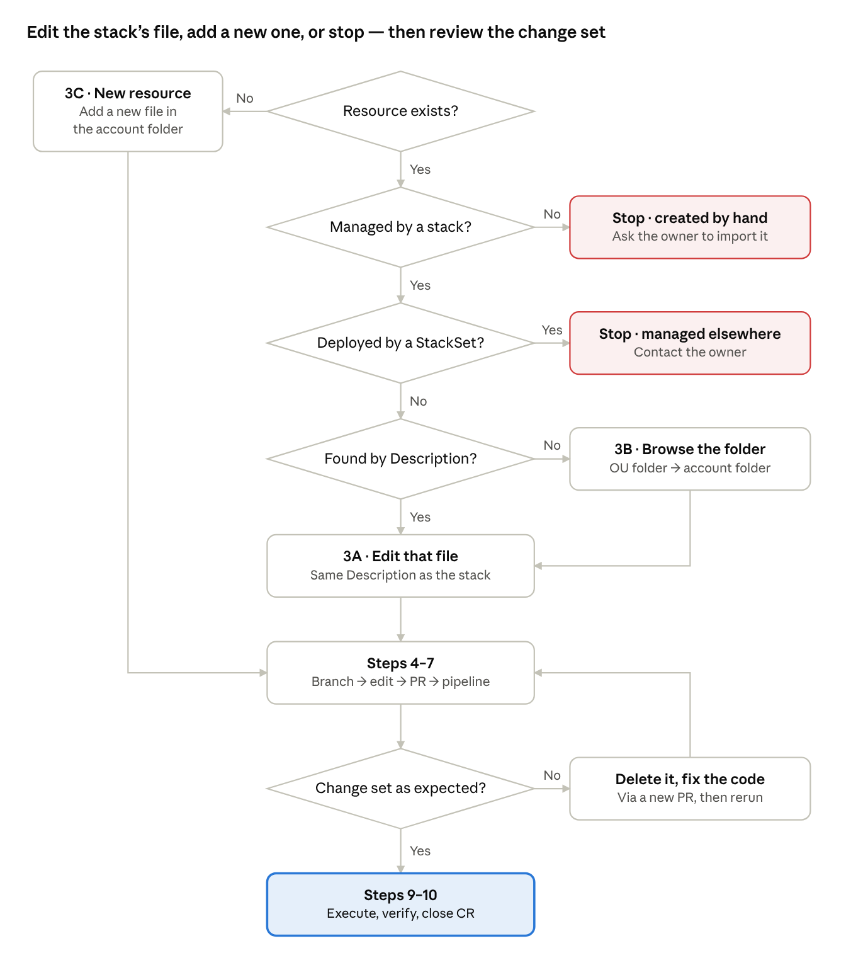
decision flow · 5 questions, 2 stops
Most changes run straight down the middle: stack found, file edited, change set reviewed and executed.

Step 1 — Does the resource exist?
Search for the resource in the target account and region before you write any code.
- Sign in through AWS SSO (<sso-portal-url>) → target account → <permission-set>.
- Set the region (top right) to <region>.
- Open the service's console and search by name or ID.
  - Not sure which service? Resource Groups & Tag Editor → Tag Editor → region <region>, resource types All supported resource types → Search resources, then filter by name.
- Found → Step 2. Not found → Step 3C (new resource).
Example (sandbox): S3 → Buckets → search sbx-runbook-demo → bucket found.
[Screenshot S3] S3 › Buckets, search box filtered to sbx-runbook-demo. Highlight: the bucket row and the account name (top right).
↑ Back to the end-to-end summary

Step 2 — Is it managed by a stack?
Check the resource's tags: aws:cloudformation:stack-name names the stack that owns it.
- Open the resource → Tags (S3: Properties tab → Tags).
- Tag aws:cloudformation:stack-name present → its value is the stack name.
- No tag? Not every resource carries it. Open CloudShell (terminal icon, top bar) and run:
# <name-or-id> = bucket name, security group ID, IAM role name, ...
aws cloudformation describe-stack-resources \
--physical-resource-id <name-or-id> \
--query 'StackResources[0].StackName' --output text
Stacks are regional. For global resources (IAM, Route 53, CloudFront), add --region <stack-region>.
Result | Next
Stack name returned | Step 3A
Name starts with StackSet- | Stop. Deployed centrally from another account. Contact <platform-owner>.
Stack is on the direct deployment list <link> (JSON settings, e.g. Firewall Manager policies) | Step 3A as usual, then run <direct-deploy-workflow> in Step 7.
Error: stack does not exist | Stop. Resource was created by hand. Ask <owner> to import it into a stack; do not recreate it.
Example (sandbox): bucket tag aws:cloudformation:stack-name = sbx-runbook-demo.
[Screenshot S4] S3 › bucket › Properties › Tags. Highlight: aws:cloudformation:stack-name = sbx-runbook-demo.
[Screenshot S5] (Optional) CloudShell with the command and the stack name it returns.
↑ Back to the end-to-end summary

Step 3 — Find the code
Copy the stack's Description and search for it in GitHub; the template with the same Description is the file to edit.

3A — Stack found: search by Description
- CloudFormation → Stacks → open the stack → Stack info tab → copy Description.
- In GitHub, search: repo:plat-eng/AWS-Landing-Zone "<description>"
- Open the matching .yaml. Its path shows the OU folder and account folder. More than one hit → take the one under the stack's account folder.
GitHub code search covers the default branch (main) only. Code that exists only on a branch won't show up.
Example (sandbox): Description SBX | runbook demo | S3 bucket → non-production/<sandbox-account-name>/sbx-runbook-demo.yaml.
[Screenshot S6] CloudFormation › Stacks › sbx-runbook-demo › Stack info. Highlight: Description.
[Screenshot S7] GitHub search results for the Description. Highlight: the file path.

3B — Search finds nothing: browse the folder
- Find the account's OU in the Repo layout table above.
- Open <OU folder>/<account folder>/. Press t to search file names for the stack name.
- Still nothing → the code is not in this repo. Stop and contact <owner>.

3C — New resource: add new code
- Same component as an existing stack in the account folder → add it to that template.
- Otherwise → new file <OU folder>/<account folder>/<stack-name>.yaml.
- Give every template a unique Description; it's how the next person finds the file.
AWSTemplateFormatVersion: '2010-09-09'
Description: '<ENV> | <component> | <what this stack manages>' # unique and searchable
Resources:
<LogicalId>:
Type: <AWS::Service::Resource>
Properties:
<property>: <value>
↑ Back to the end-to-end summary

Step 4 — Create a branch
Create your branch from main on GitHub and name it by the IMS rule.
- Open plat-eng/AWS-Landing-Zone.
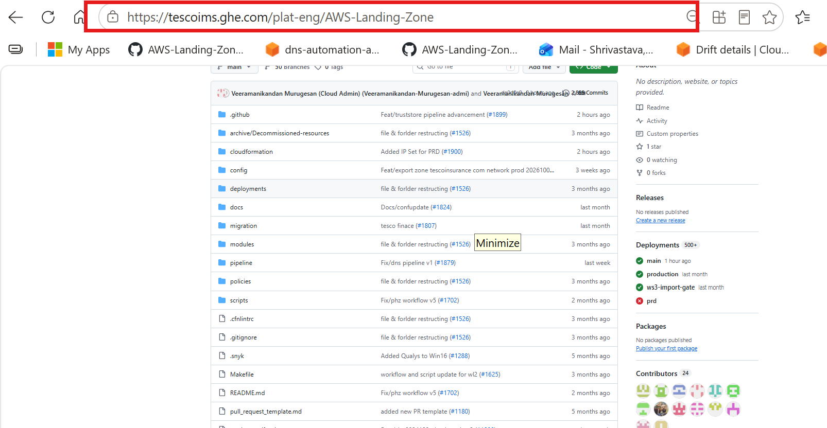
- Click Branches, next to the branch selector.
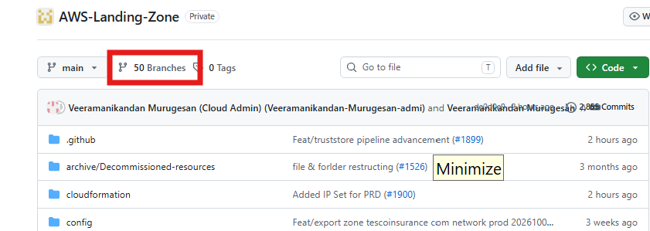
- Click New branch (top right).
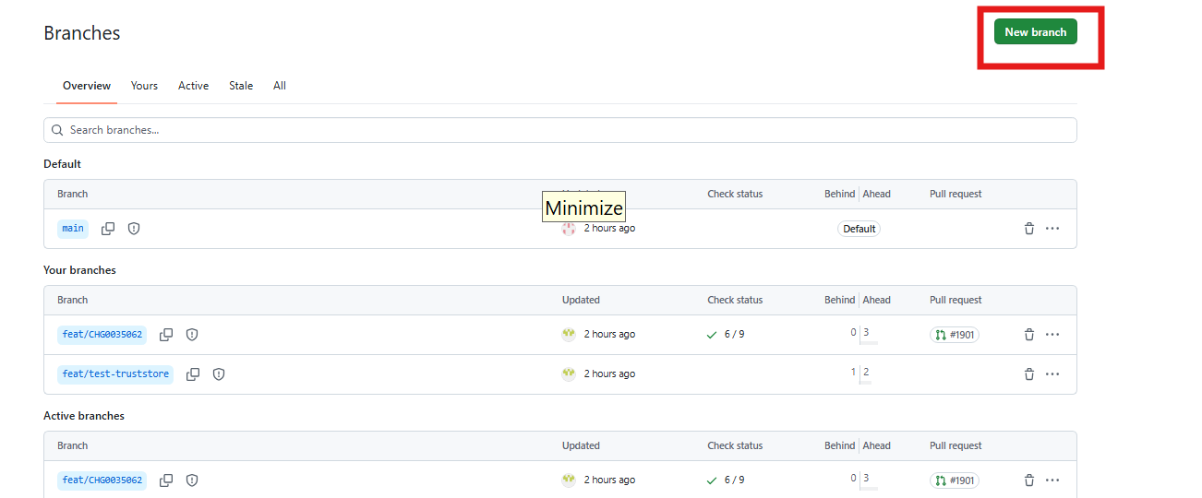
- Type the branch name, keep Source = main, then click Create new branch.
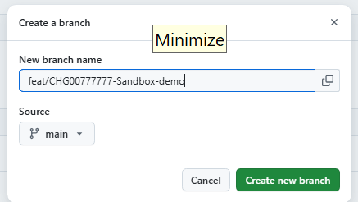
- The branch appears under Your branches. Click its name.
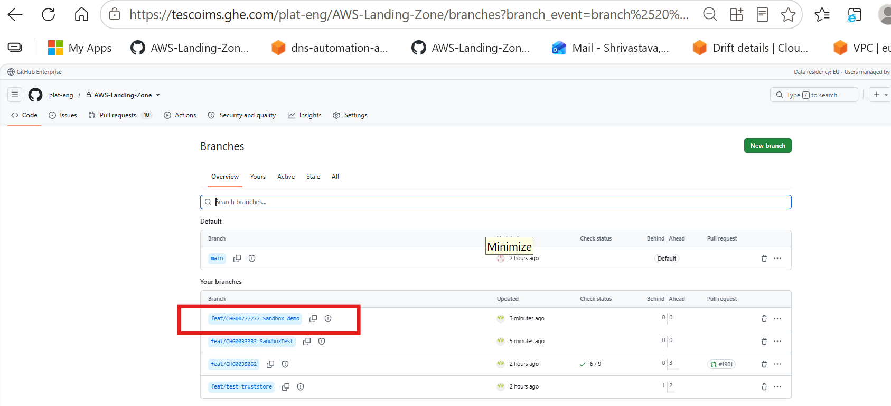
- Check the address bar ends in /tree/<branch-name> and the branch selector shows your branch. You're now on your branch.
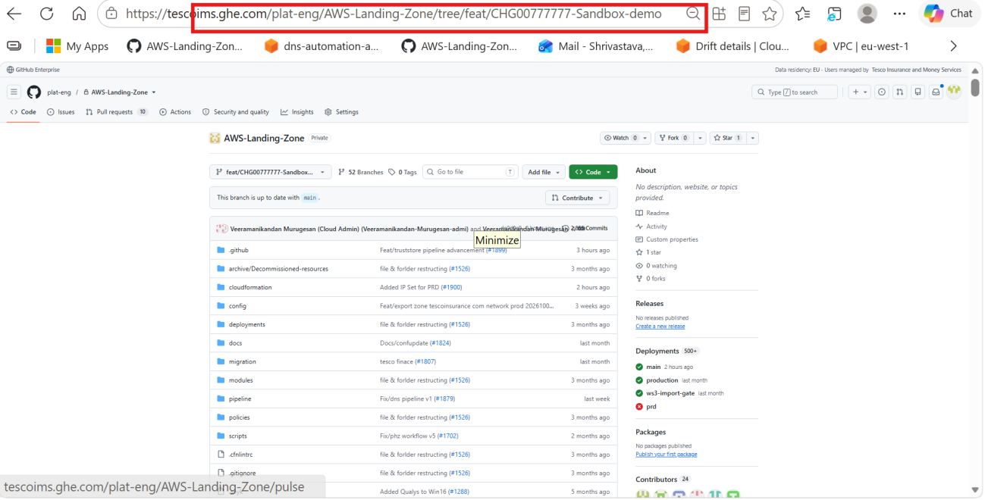
Branch name (IMS rule): <type>/<JIRA-ID>-<short-description>, lowercase, with hyphens between words.
Type | Use for
feat/ | New features
fix/ | Bug fixes to existing releases
chore/ | Maintenance, dependency updates, IaC changes
docs/ | Documentation only
hotfix/ | Urgent production fixes
Example (sandbox): chore/<JIRA-ID>-sbx-bucket-versioning
↑ Back to the end-to-end summary

Step 5 — Edit the file and commit
Edit the template on your branch with the pencil icon, and commit with the ticket number in the message.
- On your branch (the branch selector shows its name, not main), click through the folders to the template.
- Click the pencil icon (Edit this file) and make the change.
- Commit changes… → message <ticket>: <what changed> → keep Commit directly to the <your-branch> branch → Commit changes.
- New file instead? On your branch: Add file → Create new file, type the full path, paste the template, and commit the same way.
Example (sandbox): open non-production/<sandbox-account-name>/sbx-runbook-demo.yaml and add versioning. Keep LoggingConfiguration on every S3 bucket; a landing zone control requires it.
DemoBucket:
Type: AWS::S3::Bucket
Properties:
BucketName: !Sub 'sbx-runbook-demo-${AWS::AccountId}'
LoggingConfiguration:
DestinationBucketName: <access-log-bucket>
+ VersioningConfiguration:
+ Status: Enabled
[Screenshot S10] The template opened on your branch. Highlight: the branch selector and the pencil icon.
[Screenshot S11] Commit changes dialog. Highlight: message and "Commit directly to the … branch".
↑ Back to the end-to-end summary

Step 6 — Raise a PR and merge
Two people must approve the PR before it's merged.
- Pull requests → New pull request (or the Compare & pull request banner).
- base: main ← compare: your branch. Files changed must show only your change.
- Title, per the IMS rule: the ServiceNow change number first (if there is one), then the AWS account and the resource, then a short description, e.g. <CHG-number> <sandbox-account-name> sbx-runbook-demo: enable bucket versioning. In the description, say which stack it changes and what the change set should show.
- Add two reviewers (<reviewer-or-team>) → Create pull request.
- After two approvals: Merge pull request → Confirm merge → Delete branch. Close any PR you won't merge; IMS asks for no stale branches or PRs.
[Screenshot S12] New pull request. Highlight: base ← compare branches and Files changed.
[Screenshot S13] Pull request with two approvals. Highlight: the approvals and Merge pull request.
↑ Back to the end-to-end summary

Step 7 — Run the pipeline
Straight after the merge, run the deploy workflow from main with Deploy = no: it runs a drift check, creates the change set, and stops.
- Actions tab → select <cfn-deploy-workflow> in the left list.
- Click Run workflow (right side).
- Use workflow from: main. Fill the parameters (table below) → Run workflow.
- Open the run and wait for the green tick.
- In the log, note the drift check result and the change set name.
Parameter | Enter | Sandbox example
Use workflow from | main | main
<template-input> | Path to the template | non-production/<sandbox-account-name>/sbx-runbook-demo.yaml
<deploy-input> | no (change set only) | no
<other-inputs> | Account / stack / region, if asked | <sandbox-account-id> / sbx-runbook-demo / <region>
Drift check shows DRIFTED → stop. Someone changed the resource in the console; contact <owner> before going on.
[Screenshot S14] Actions › <cfn-deploy-workflow> › Run workflow panel, filled in. Highlight: main, template path, Deploy = no.
[Screenshot S15] Finished run log. Highlight: drift check result and change set name.
Stack on the direct deployment list? Run <direct-deploy-workflow> instead, with the template path and <direct-deploy-inputs>. It deploys straight away, with no drift check and no change set: skip Step 8, and in Step 9 watch the stack's Events, then run the resource check.
↑ Back to the end-to-end summary

Step 8 — Review the change set
Open the change set in the CloudFormation console and check every row before you execute.
- AWS console (target account, <region>) → CloudFormation → Stacks → open the stack. A new stack shows status REVIEW_IN_PROGRESS.
- Change sets tab → open the change set named in the pipeline log.
- Read the Changes table. For before/after values, click View details (Property-level changes) or open the JSON changes tab.
Column | OK | Stop and get a review
Action | Add or Modify you expected | Remove, or a row you didn't change
Replacement | False | True (deleted and recreated: new ID, possible outage or data loss) or Conditional
Logical ID | Only resources you touched | Others → another merged change to this template isn't deployed yet
Example (sandbox): one row — Modify · DemoBucket · AWS::S3::Bucket · Replacement False.
[Screenshot S16] Stack › Change sets tab. Highlight: change set name, status CREATE_COMPLETE, execution status AVAILABLE.
[Screenshot S17] Change set › Changes table. Highlight: Action = Modify, Replacement = False.
Not what you expected → Delete the change set, fix the code through a new PR (Steps 4–6), then rerun Step 7.
↑ Back to the end-to-end summary

Step 9 — Execute the change set and verify
Execute the change set, then watch the stack until it reaches UPDATE_COMPLETE (CREATE_COMPLETE for a new stack).
- On the change set page → Execute change set.
- Stack failure options: keep Roll back all stack resources → Execute change set.
- Events tab → refresh until UPDATE_COMPLETE or CREATE_COMPLETE.
- Check the resource itself.
Example (sandbox): S3 → bucket → Properties → Bucket Versioning: Enabled.
[Screenshot S18] Execute change set dialog. Highlight: "Roll back all stack resources".
[Screenshot S19] Stack › Events. Highlight: UPDATE_COMPLETE.
[Screenshot S20] S3 › bucket › Properties. Highlight: Bucket Versioning = Enabled.
Ends in UPDATE_ROLLBACK_COMPLETE or ROLLBACK_COMPLETE → see Troubleshooting.
↑ Back to the end-to-end summary

Step 10 — Close the CR
Close the CR only after the stack reaches UPDATE_COMPLETE (or CREATE_COMPLETE) and the resource check in Step 9 passes.
- Open the CR <CHG-number> in ServiceNow.
- In Work notes, add the evidence below. Evidence missing? Say so in the notes; don't leave it out.
Evidence | Where to find it
Merged PR link (code diff and both approvals) | GitHub → Pull requests → Closed
Pipeline run link | GitHub → Actions → your run
Drift check result and change set name | The run log
Final stack status | CloudFormation → stack → Events
Resource check | Screenshot of the Step 9 check
- Set Close code to match what happened: Successful only if every check passed; otherwise Successful with issues or Unsuccessful, with the reason.
- Write Close notes: what changed, in which account and stack, and the final status.
- Move the CR to <cr-close-state> (for example Review, then Closed), as your change process requires.
Example close notes: Enabled versioning on bucket sbx-runbook-demo-<account-id> (stack sbx-runbook-demo, <sandbox-account-name>). Change set executed; stack UPDATE_COMPLETE; versioning verified.
[Screenshot S21] ServiceNow CR with work notes and close details filled in. Highlight: State, Close code, Close notes. Reusable across runbooks.
↑ Back to the end-to-end summary

Troubleshooting
Find the symptom, apply the fix, then rerun from the step shown.
Symptom | Likely cause | Fix
Can't see the stack or change set | Wrong account or region selected | Check the account name and region (top right).
Merge pull request is disabled (merging is blocked) | Fewer than two approvals, or checks still running | Wait for both approvals and green checks.
Pipeline fails at the AWS credentials step (AssumeRoleWithWebIdentity or AssumeRole denied) | Repo not trusted by the deploy role, or the role is missing in the target account | Contact <owner>. Don't edit IAM trust policies yourself.
Change set FAILED: "didn't contain changes" | The template on main already matches what's deployed | Check the PR was merged and the template path in Run workflow is right.
Drift check shows DRIFTED | Someone changed the resource in the console | Stop. Contact <owner> to reconcile first.
Change set shows changes you didn't make | Another merged change to the same template hasn't been deployed yet | Don't execute. Check the file's history on main with <owner>.
UPDATE_ROLLBACK_COMPLETE | A resource failed: permissions, an invalid value, or a landing zone control (e.g. S3 bucket without logging) | Events tab → first *_FAILED reason → fix through a new PR (Steps 4–6) → rerun Step 7.
New stack ends ROLLBACK_COMPLETE | The first create failed | Delete the stack, fix through a new PR, rerun Step 7.
Stack stuck in REVIEW_IN_PROGRESS | A new stack's change set was never executed | Execute it, or delete the empty stack.
Drift check shows DRIFTED every time on a stack with JSON settings (e.g. a Firewall Manager policy) | CloudFormation can't compare JSON settings reliably | Use the direct deployment pipeline for that stack, and add the stack to the direct deployment list.

References
Official pages behind the console and search behaviour described above.
- View a change set — AWS CloudFormation
- Example change sets: how Replacement is set — AWS CloudFormation
- Resource tagging: automatic aws:cloudformation:* tags — AWS CloudFormation
- describe-stack-resources — AWS CLI
- Using GitHub code search: default branch only — GitHub Docs

Review notes (delete before publishing)
Settle the open points, fill the placeholders, then capture S3–S21 in order during one sandbox run. S1–S2 come from your OU diagram and the repo. S8 and S9 aren't needed any more: Step 4 has the real branch screenshots.

Using this as a template
- Start each task doc from this one and retitle it, e.g. "How to add a DNS record to a Route 53 hosted zone".
- In Section 1, replace Task details and Change with the task's values.
- Keep Section 2 as is, so the screenshots are captured once.
- Optional: keep Section 2 in one shared doc and link to it from each task doc, so a pipeline change is updated in one place.

Open points
- ☐ Pipelines: real names and inputs of the three workflows (<cfn-deploy-workflow>, <direct-deploy-workflow>, <truststore-workflow>).
- ☐ Drift check: does it fail the run, or only log a warning?
- ☐ Naming: is every file named after its stack? Is the account folder the account name or ID?
- ☐ OU coverage: is sandbox in the Non-Production OU? Are accounts in other OUs (e.g. Security) in this repo?
- ☐ Description convention for new templates (draft: <ENV> | <component> | <what>).
- ☐ Production rule: change record required?
- ☐ Direct deployment list: where it lives (<link>), which stacks are on it, and who keeps it current.
- ☐ Demo stack: create sbx-runbook-demo in sandbox from main, versioning off, before taking screenshots.
- ☐ Repo paths: the repo root in the Step 4 screenshots has cloudformation/, deployments/ and other folders, but no top-level production/ or non-production/. Confirm the full path, then update the folder tree, Task details and the Step 7 example.
- ☐ Branch screenshot: it shows feat/CHG00777777-Sandbox-demo, but the IMS rule asks for a Jira ID and lowercase. Keep it, or retake it with a compliant name.
- ☐ CR closure: who closes the CR, which states it moves through (fill <cr-close-state>), and whether non-production changes need a CR at all.

Placeholders
Placeholder | Value
<sso-portal-url>, <permission-set>
<region>
<sandbox-account-name>, <sandbox-account-id>
<cfn-deploy-workflow>, <direct-deploy-workflow>, <truststore-workflow> and their inputs (<direct-deploy-inputs>)
<link> to the direct deployment list
<cr-close-state>
<owner>, <platform-owner>, <reviewer-or-team>

